Signs with Smart Connectivity for Better Road Safety TEAM ID - PNT2022TMID00982

CREATE NODE-RED SERVICE

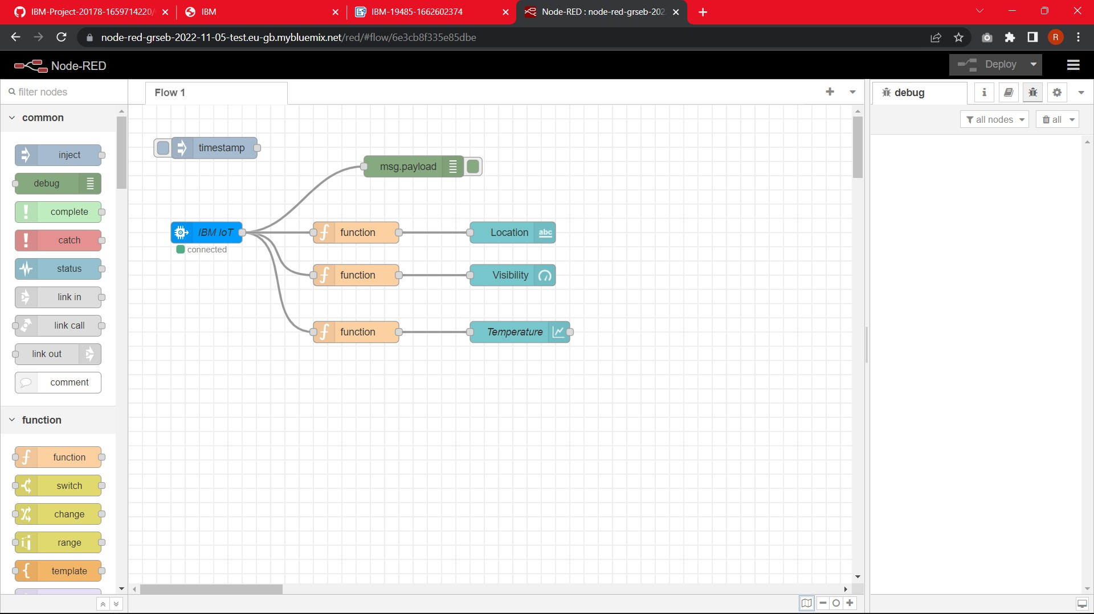

Signs with Smart Connectivity for Better Road Safety TEAM ID - PNT2022TMID00982

